Swarthmore College Biology Department
T-Shirt Order Form
APRIL 15th DEADLINE
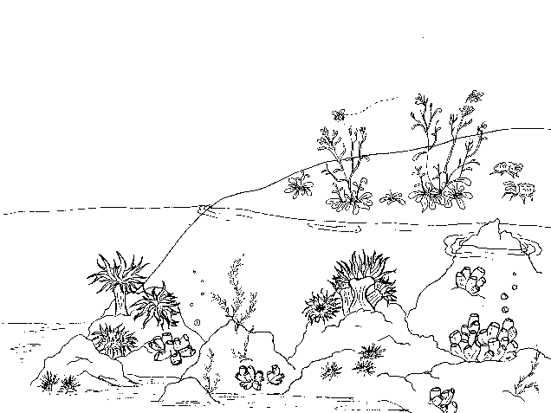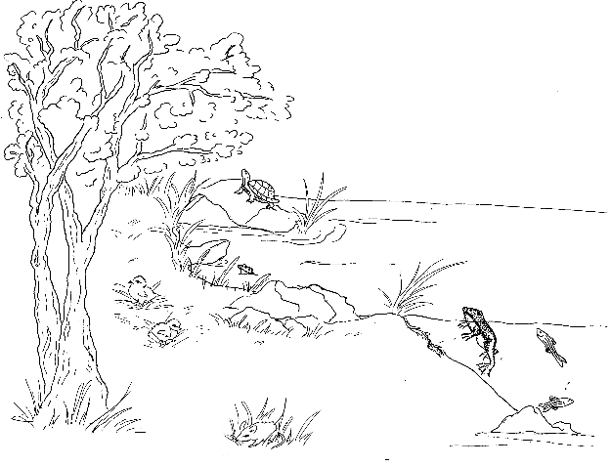
Swarthmore College Biology

Get a blue department t-shirt!

Name (First and Last):________________________________
Email:_____________________________________________
Staff, Faculty, or Student:_____________________________
Quantity and Sizing:
___S | ___XL | ___3XL
___M | ___XXL | ___4XL
___L

Total Cost:
Quantity x $11.76= ______________

Or use the link to order and pay online: ($11.76/shirt)
https://www.customink.com/g/kmw0-00ag-wz0e.
Office Hours for Cash and Change forms

M: 4:15-5pm
T: 3:30-5pm
W: 10:30am-11:30am
F: 10-11am, 2-4pm
S/S: 3pm-5pm

*The t-shirt project is the responsibility of the Swarthmore Biology Club; the cost is not being funded or supplemented by the Biology Department and the order process is entirely student- run. We will NOT order a shirt without first receiving payment. All questions, comments, and concerns about ordering and payment should be directed to sschick1@swarthmore.edu.

